11.43: For the airplane to remain in level flight, both 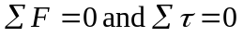.

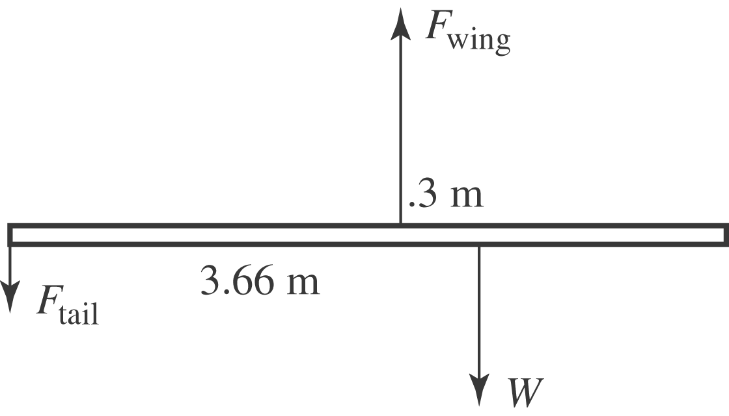
Taking the clockwise direction as positive, and taking torques about the center of mass,

Forces: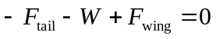

Torques: 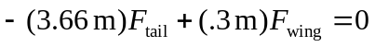

A shortcut method is to write a second torque equation for torques about the tail, and solve for the This gives

Note that the rear stabilizer provides a downward force, does not hold up the tail of the aircraft, but serves to counter the torque produced by the wing. Thus balance, along with weight, is a crucial factor in airplane loading.

